Binary Search
Binary Search is an algorithm for finding an element's position in a sorted array.
In this approach, the element is always searched in the middle of a portion of an array.
Binary search can be implemented only on a sorted list of items. If the elements are not sorted already, we need to sort them first.

Binary Search Working
Binary Search Algorithm can be implemented in two ways which are discussed below.
- Iterative Method
- Recursive Method
The recursive method follows the divide and conquer approach.
The general steps for both methods are discussed below.
- The array in which searching is to be performed is: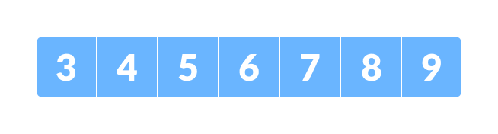Initial array
Let x = 4 be the element to be searched.
- Set two pointers low and high at the lowest and the highest positions respectively.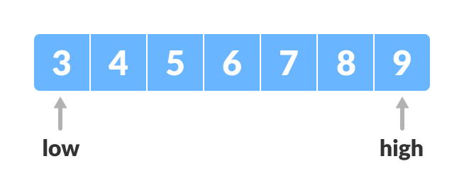Setting pointers
- Find the middle position mid of the array ie. mid = (low + high)/2 and arr[mid] = 6.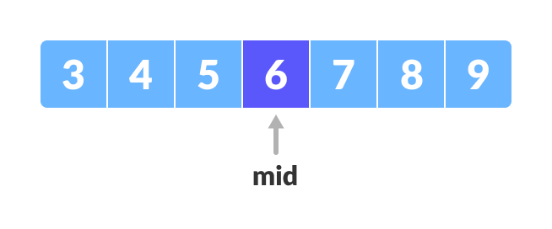Mid element
- If x == arr[mid], then return mid. Else, compare the element to be searched with arr[mid].
- If x > arr[mid], compare x with the middle element of the elements on the right side of arr[mid]. This is done by setting low to low = mid + 1.
- Else, compare x with the middle element of the elements on the left side of arr[mid]. This is done by setting high to high = mid - 1.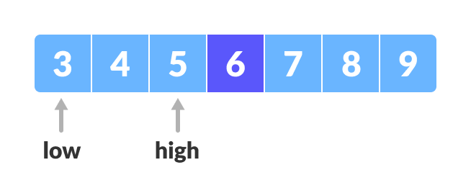Finding mid element
- Repeat steps 3 to 6 until low meets high.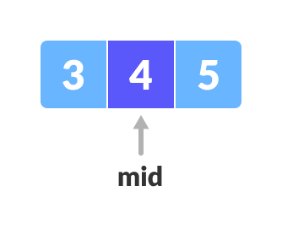Mid element
- x = 4 is found.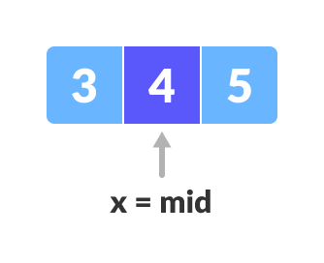Found

Binary Search Algorithm

Iteration Method
do until the pointers low and high meet each other.
mid = (low + high)/2
if (x == arr[mid])
return mid
else if (x > arr[mid]) // x is on the right side
low = mid + 1
else // x is on the left side
high = mid - 1

Recursive Method
binarySearch(arr, x, low, high)
if low > high
return False
else
mid = (low + high) / 2
if x == arr[mid]
return mid
else if x > arr[mid] // x is on the right side
return binarySearch(arr, x, mid + 1, high)
else // x is on the left side
return binarySearch(arr, x, low, mid - 1)

Java, (Iterative Method)

class BinarySearch {
int binarySearch(int array[], int x, int low, int high) {

// Repeat until the pointers low and high meet each other
while (low <= high) {
int mid = low + (high - low) / 2;

if (x == array[mid])
return mid;

if (x > array[mid])
low = mid + 1;

else
high = mid - 1;
}

return -1;
}

public static void main(String args[]) {
BinarySearch ob = new BinarySearch();
int array[] = { 3, 4, 5, 6, 7, 8, 9 };
int n = array.length;
int x = 4;
int result = ob.binarySearch(array, x, 0, n - 1);
if (result == -1)
System.out.println("Not found");
else
System.out.println("Element found at index " + result);
}
}

(Recursive Method)

def binarySearch(array, x, low, high):

if high >= low:

mid = low + (high - low)//2

# If found at mid, then return it
if x == array[mid]:
return mid

# Search the right half
elif x > array[mid]:
return binarySearch(array, x, mid + 1, high)

# Search the left half
else:
return binarySearch(array, x, low, mid - 1)

else:
return -1

array = [3, 4, 5, 6, 7, 8, 9]
x = 4

result = binarySearch(array, x, 0, len(array)-1)

if result != -1:
print("Element is present at index " + str(result))
else:
print("Not found")

Binary Search Complexity
Time Complexities
- Best case complexity: O(1)
- Average case complexity: O(log n)
- Worst case complexity: O(log n)
Space Complexity
The space complexity of the binary search is O(1).

